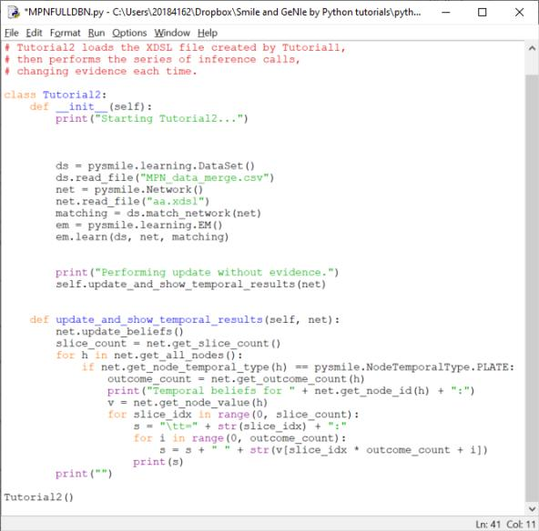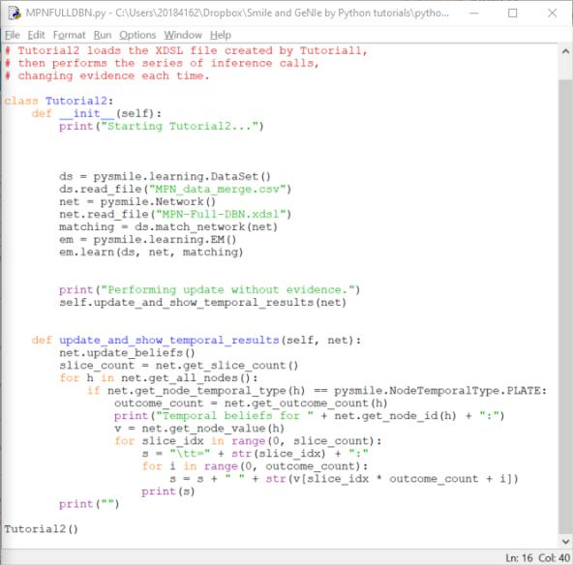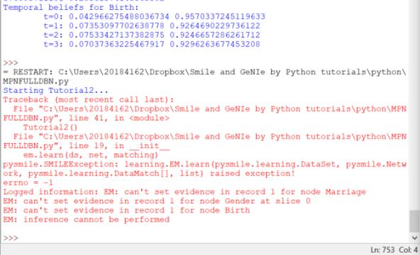
2
1
3
Q1: I use the same dataset to create two DBN network, the picture 1 is the simple DBN network, and I can see the all Temporal beliefs for nodes from time 0 to time 3. However, when I change the complex DBN file.xdsl like picture 2, I only change the net.read_file(‘name’), I can not get the beliefs of nodes, and get some errors. You can see the error(red words) in picture 3. The error said: EM: can’t set evidence in record 1 for node Birth, etc. Could you please tell me how can I solve this problems?
Q2: I use the simple file.xdsl and same datasets to make the validator according to the SMILE manual, I have not add anything but the code provided by manual, as shown in picture 4, but I also get the error, as shown in picture 5. could you please tell me what should I add or change my code?
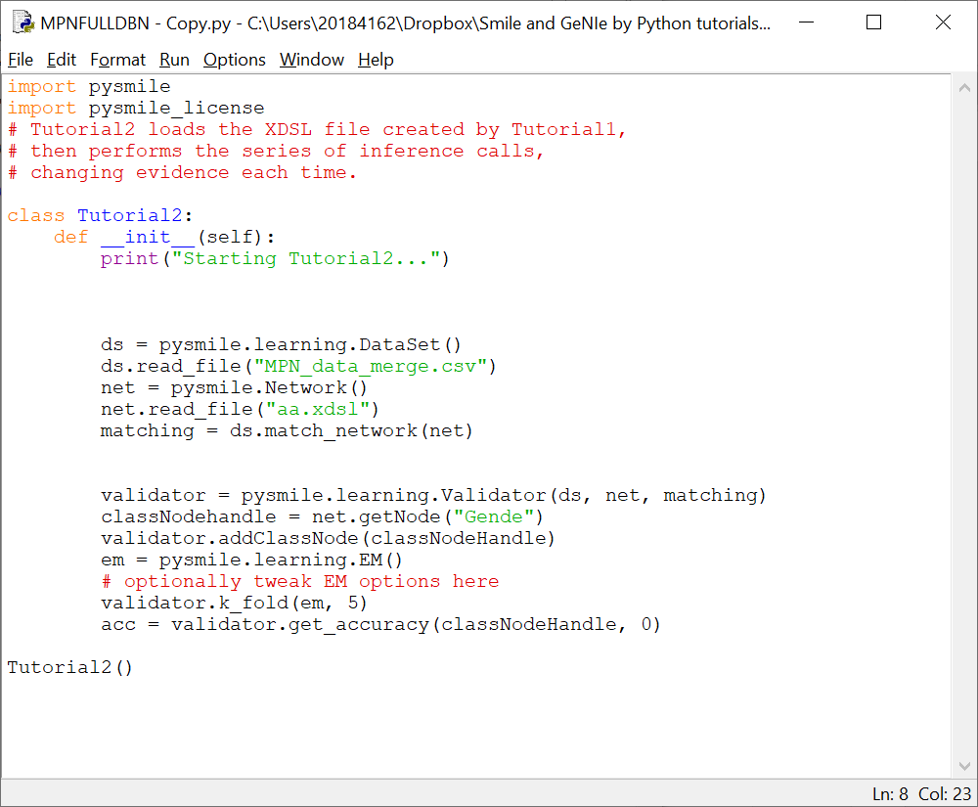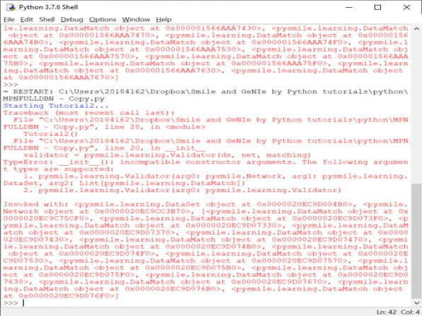
5
4
Q3: to solve my Q1, I try to set target nodes, like 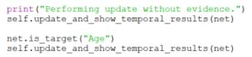, but I also get the beliefs of all nodes twice, why my target nodes seems useless? Actually, I want to set “Event 1”,”Event 2” and much more nodes like “Event n” as target nodes to decrease the calculation time. Does the code is net.is_temporal_target(“Age”) or net.is_target(“Age”) if I want to set target nodes like I set them in temporal plate area in GeNIe?
Q4: I want to use the probability of nodes like “EVENT1”, “Event 2”,etc to simulate what kind of state they will use, like for item 1, the probability of Event 1 is (0.75,0.01,0.2,0.04) for state 1 to state 4. I want to add a simulate procedure by this probability, then add a new column to store the simulated state of Event1. Could you please tell how can I extract this probability of nodes after self.update_and_show_temporal_results(net)?
Thank you very much! I have so many difficulties, and I am not familiar with python, I am learning how to use them better. Thanks again!

